WEB DESIGN
PROJECT REPORT

PROJECT TEAM
Student No. | Student Names
16135008 | Ronan Hoyne
16135024 | Martin O'Sullivan
16140435 | Sigmund Vestergaard

** Yummy Food Restaurant **

** https://yummyfoods.github.io/index.html **

Section 1: Design

- PROJECT PROPOSAL

Project Overview
Yummy Food Restaurant requires a website for its business, this website will advertise the restaurant, allow customers to book a table, order food as well as allowing them to view the Menus and view some of our receipts and view some demo videos. At this stage of development, we want to have all our pages defined using the wireframe in Balsamiq. And we created a plan to divide out the work to create the individual pages among the team.

Research / Investigation
- Toscana, http://www.toscanarestaurant.ie/index.php
- Gotham Café, http://gothamcafe.ie/
- White Friar Grill, http://www.whitefriargrill.ie
- The Quays, http://www.quaysrestaurant.com/

The competitors we looked at all had a high-quality web presence. Their websites were modern, and designed well, to appeal to their audience.
As our competitor’s sites were well designed, and had a hi degree of functionality, we designed our site using the below criteria
Usability

We have designed our website so that it is usable by as many people as possible. We have tested our design both from the point of view of a mobile and desktop user. We have also tested our site with a screen reader to test its usability by people who are using assistive technology.

Visual Hierarchy
We have arranged and organised our website elements so that visitors naturally gravitate toward the most important elements first.
Navigability
we designed our site to have intuitive navigation, when a visitor lands on the site, they can see at a glance exactly where to go to accomplish what they need to do.
Consistency
the overall look and feel of our site is consistent across all our site's pages. We have kept Backgrounds, colour schemes, typefaces, and style consistent. This will increase the usability, as the visitor does not have to learn a new way of doing things on each page.
Conventional Design
We have designed our website so that It looks and behaves like other websites in our industry. This will allow the customer to bring their experience of other websites to our website, without having to learn a whole new interface.

Requirements & Technical Approach

The restaurant requires a website which will:

- Give the customer an impression of the dining experience on offer.
- Let customers view the current menu.
- Enable customers to order takeaway, or book a meal.
- Give customers a chance to see one of the ways in which their food is prepared.
- Inform customers the location of the restaurant and give contact details.

To achieve this the website has been designed using html 5 and java script, the website is light by design, and loads fast.

When the customer first enters the site, they are greeted by a welcoming image, and the controls of the website are placed at the top for ease of use.

From here the customer can browse the menu, or go straight to book their meal.

To allow customers to book their meal, or contact the restaurant, an html contact form has been designed which takes advantage of html 5 tags to allow for easier completion of the form.

The site allows customers to view cooking demonstrations, this has been implemented in a gallery style video page, which invites the customer to view how food is prepared.

WIREFRAME / SITEMAP

** Include wireframe, and sitemap, for your website here, including brief explanations where needed, etc. **

****** The following sections should NOT be completed until you have FINISHED your website ******

Section 2: Development

- PRODUCTION LOG

** This section should outline how you went about developing your webpage, i.e. HTML, CSS, JavaScript. This should include information on requirements implementation, code development and technical details, such as errors or development issues and how you fixed these.
Please note: Make sure to include explanation (as well as comments in the HTML files) of any & all code that was taken from the web, or you will not receive marks for this third party code. **

Validation

** This section should look at validation of the website, were you able to validate the website, were there any errors and if so, how did you go about fixing them. Please include a screenshot(s) of your validation report here **

Deployment

We chose to deploy the site using GitHub, as this allows us to work on the site, and commit our changes directly on to the site. While this would not be good practice in a live website, for a project or proof of concept site, this has proven to be very useful. https://yummyfoods.github.io/
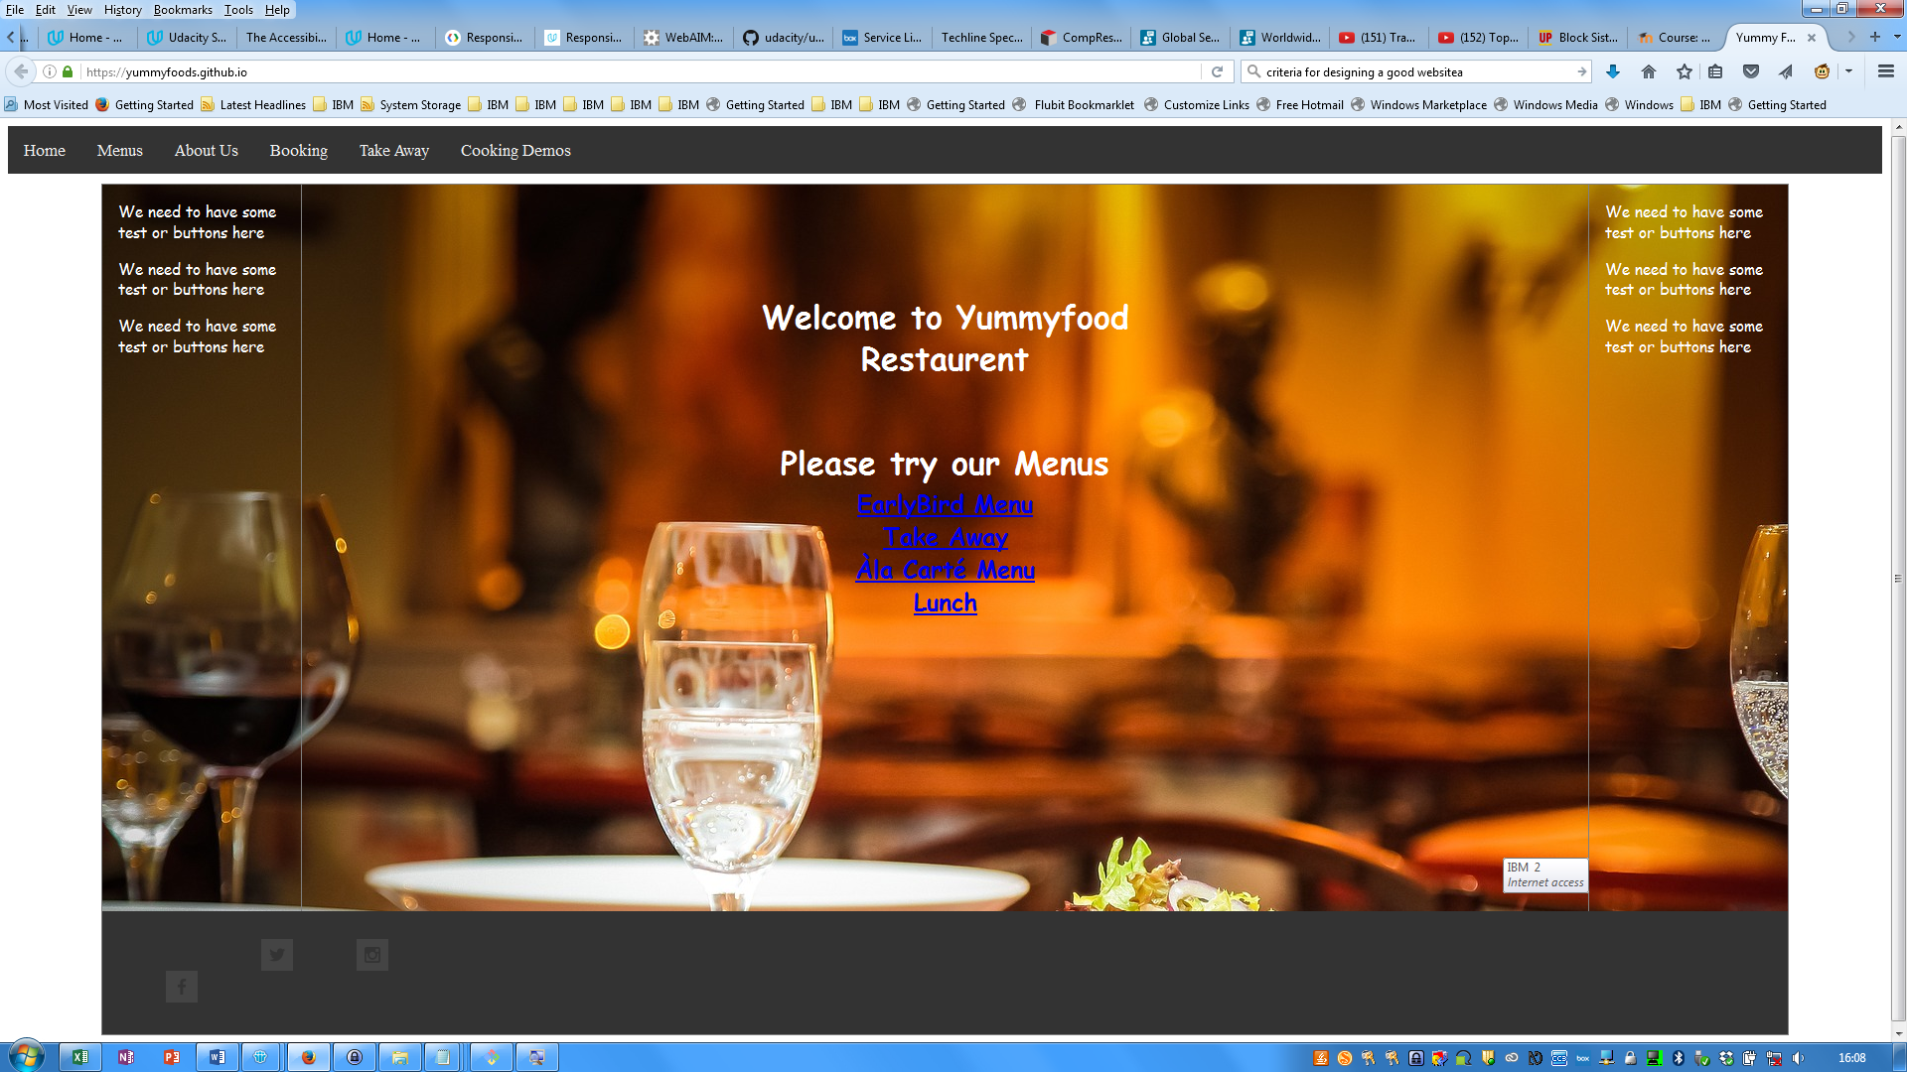

- PROJECT TEAM

We met at the start of the project, and looked at the site which we wanted to design. We decided baised on our proyer experience, to devide the tasks as follows.

Division Of Labor
Team Member. | Task(s)
Ronan Hoyne | Design, and wireframe creation Ronan Hoyne
Martin O'Sullivan | Html forms and usability testing Martin O’Sullivan
Sigmund Vestergaard | Hosting and setting up of the git repository, and ensuring deadlines were met

- CONCLUSION

** Having finished the project, looking back, how did the project go?
Did you achieve what you set out to do?
Are you happy with the results?
Is there anything you might change if you had more time? Etc. **

- REFERENCES & APPENDIX

** Make sure to include any third party resources / information / code used here.
Make sure to reference correctly as needed, i.e. Harvard Referencing, or marks will be deducted. **

